Cybersecurity Vulnerability Pre-test
Directions: Students will be given the set-up visually in front of the classroom. Students will record possible vulnerability AND possible solution on answer document. Scores will be graded based on attached rubric.
- Reverse Function Attack
  - Set-up:
    - Server and Client are trying to make connection
    - Both have a key (Red)
    - To establish link, Server sends Client a color (Purple) that is the key mixed with another color
    - Client decrypts Purple by reversing the mixing process (What color mixed with Red gives me Purple?)
    - Client sends that (Blue) back to Server
    - Server confirms and connection is established
  - Vulnerability:
    - Attacker can intercept transmissions and figure out Red by deciding which color mixed with Blue gives Purple
  - Solution:
    - Never send key without a hash function (something that can be worked backwards)
    - Use timestamp

- Time-stamp Attack
  - Set-up:
    - Server and Client are trying to make connection
    - Both have a key (Red)
    - Client sends Server { Red: Timestamp}
    - Attacker can intercept the Key but doesn’t matter because they can reproduce the timestamp
  - Vulnerability:
    - Timestamp could be a window of times
      - When two text messages send right after the other sometimes they say same time even though that is impossible (don’t include milliseconds)
    - Attacker could set time back on server
    - If multiple servers, attacker could use Red on different server avoiding the timestamp
  - Solution:
    - Require server to show all times
    - Use key {Red: Timestamp / Server}
**Could also be used with hash function but server impersonation is still vulnerability
- Man in the middle Attack
  - Set-up:
    - Server and Client are trying to make connection
    - Both have a key (Red) which is unknown to any outsider
    - To establish link, Server sends Client Blue
    - Client accepts Blue – mixes with Red – sends back Purple
    - Server mixes Red with Blue as well and confirms Purple
    - Since both Client and Server get same color – connection is established
  - Vulnerability:
    - Attacker poses as Server and intercepts Purple
    - Attacker sends back to Client confirmation that Purple was received
    - Connection is now established between Client and Attacker and Server is left out of the loop
  - Solution:
    - Client and Server BOTH need to authenticate identities
    - For example, Client needs to also send yellow and make sure Server responds with Orange
**Colors represent one-way function
- Reflection Attack
  - Set-up:
    - Client and Server need to BOTH authenticate identity
    - Both have a key (Red) which is unknown to any outsider
    - To establish link, Client sends Server Blue
    - Server mixes Blue with Red, responds Purple but also sends its own color (Yellow) to authenticate client
    - Client confirms Purple, mixes Yellow with red and responds with Orange
    - Server confirms Orange and connection is established
  - Vulnerability:
    - Attacker attempts to establish connection with Server, sends Blue
    - Server mixes Blue with Red, responds Purple but also sends its own color (Yellow) to authenticate client
    - Attacker can’t responds because it doesn’t know what to mix with Yellow so instead pauses that connection and opens a NEW connection
    - Attacker sends Yellow to Server, server mixes with Red and responds with Orange
    - Attacker now knows what the correct response is to Yellow, goes back to paused connection and responds Orange – Connection established
  - Solution:
    - Change direction of arrows – Force client to confirm identity first

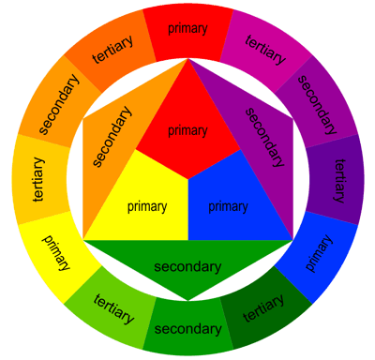
ANSWER KEY IN BLUE

